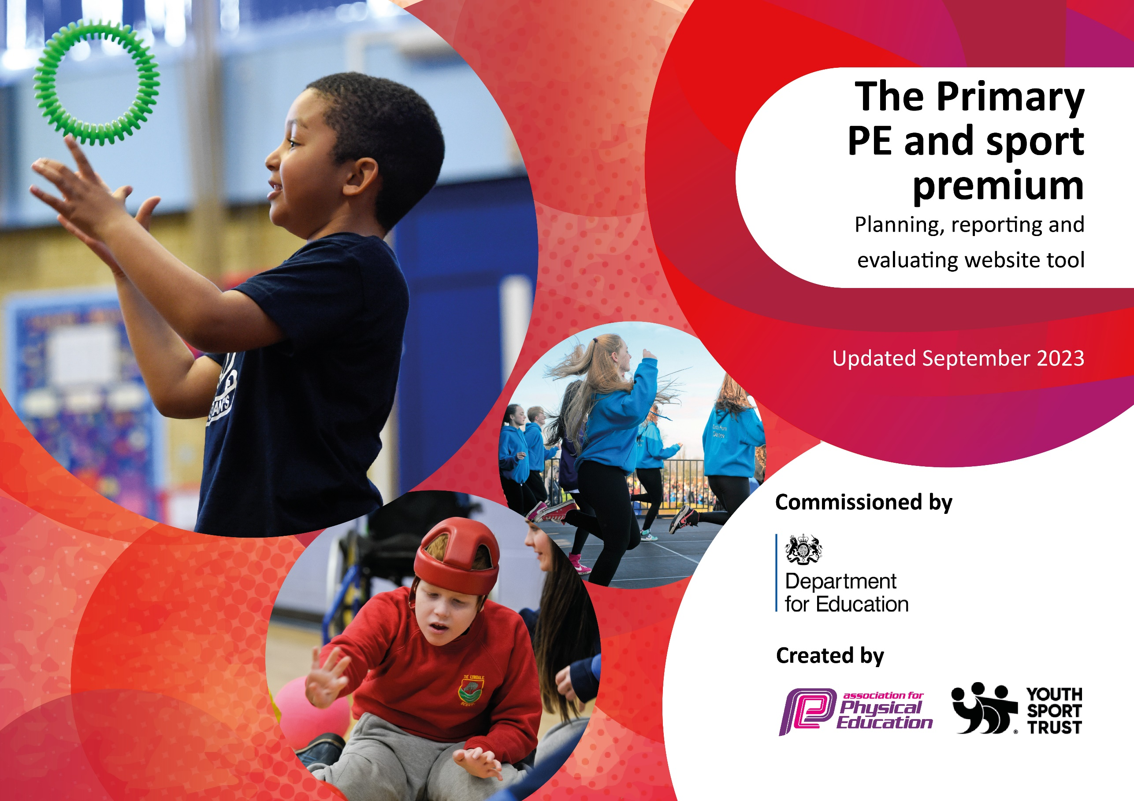

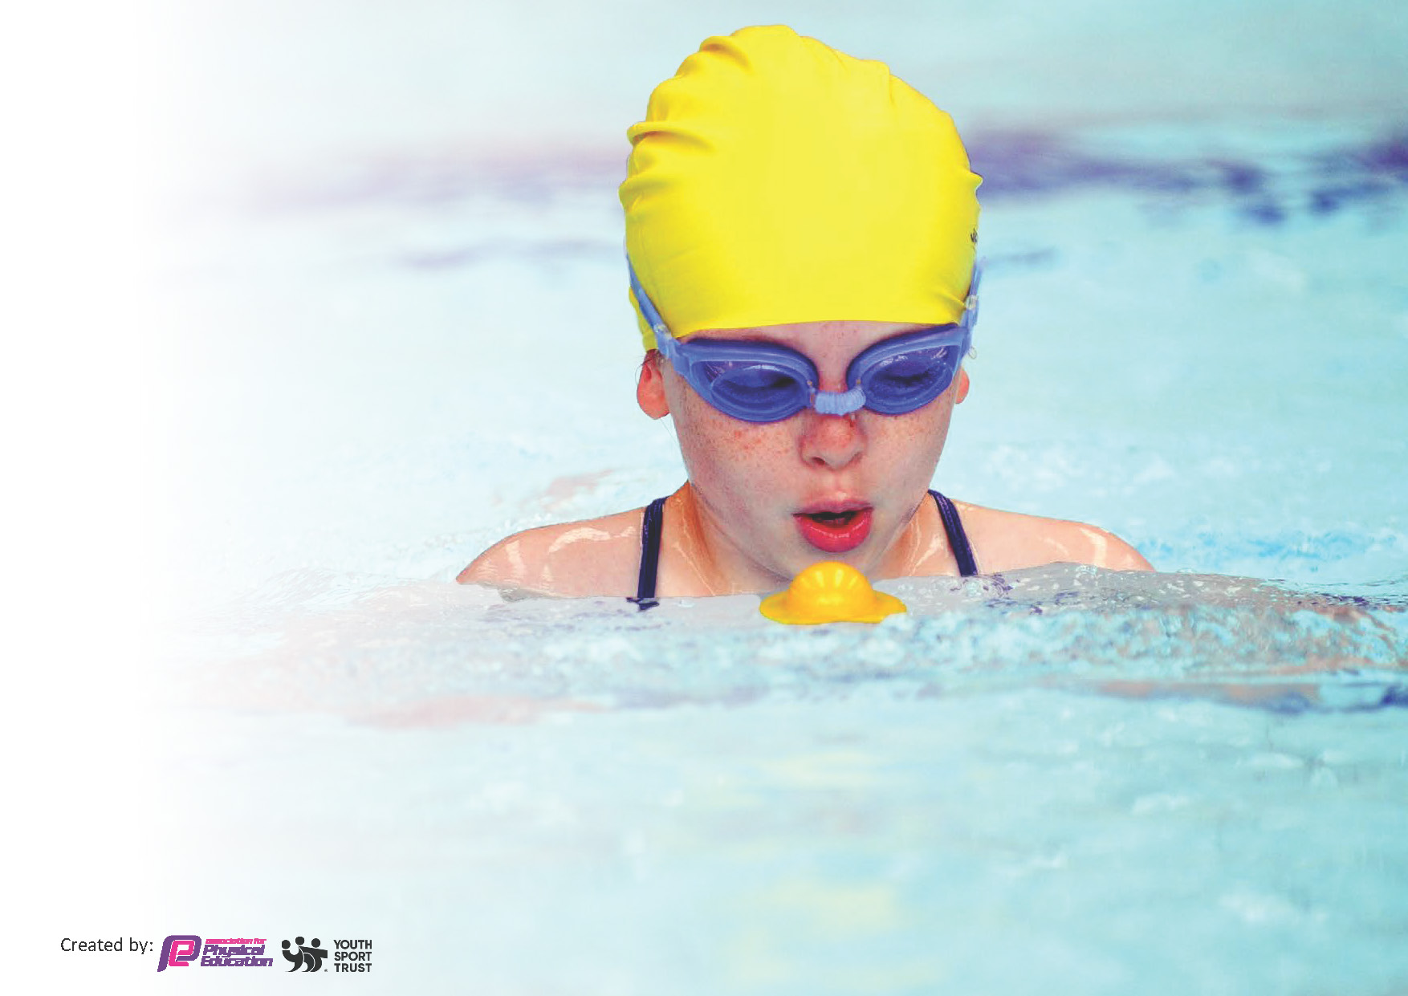
This template can be used for multiple purposes:
by:
- It enables schools to effectively plan their use of the Primary PE and sport premium
- It helps schools to meet the requirements (as set out in guidance) to publish information on their Primary PE and sport premium
- It will be an effective document to support Ofsted inspections enabling schools to evidence progress in Physical Education (PE) and evidence swimming attainment, which forms part of the PE National Curriculum. We would recommend schools consider
the Intent, Implementation and Impact of any spend, as examined within the Education Inspection Framework.

It is important that your grant is used effectively and based on school need.

Schools must use the funding to make additional and sustainable
improvements to the quality of the PE, School Sport and Physical Activity (PESSPA)
they offer. This means that you should use the Primary PE and sport premium to:

- Build capacity and capability within the school to ensure that improvements made now will benefit pupils joining the school in future years
- Develop or add to the PESSPA activities that your school already offers.

The Primary PE and sport premium should not be used to fund capital spend projects; the school’s core budget should fund these. Further detail on capital expenditure can be found in the updated Primary PE and sport premium guidance.

The Primary PE and sport premium guidance, outlines 5 key priorities that funding should be used towards. It is not

necessary that spending has to meet all the key priorities, you should select the priorities that you aim to use any funding towards.

Although completing this template is not a requirement for schools, schools are required to publish details of how they spend this funding. Schools must also outline what the impact this funding has had on pupils’ PE and sport participation and attainment and how any spending will be sustainable in the future. All funding must be spent by 31st July 2024.

The Department for Education has worked closely with the Association for Physical Education (afPE) and the Youth Sport Trust (YST) to develop this template and encourages schools to use it. This template is an effective way of meeting the reporting requirements of the Primary PE and sport premium.
Review of last year’s spend and key achievements (2022/2023)

We recommend you start by reflecting on the impact of current provision and reviewing your previous spend.

Activity/Action | Impact | Comments
Staff CPD in games, gymnastics and dance (provided by iMoves staff)  Disengaged children (external provider - Premier Sports)  iMoves (PE SOW)  We Are Adventurers (EYFS Forest School) | CPD empowered staff to have better subject knowledge and deliver quality PE lessons in the 3 main areas. CPD gave staff confidence in planning, delivering and assessing their class in PE lessons.  Lunchtime club, which targeted the lowest 3/4 children in each class, who were disengaged in PE lessons. These sessions ensured that these targeted children were physically active during these small-group sessions  Implementation of iMoves as the school's SOW for PE has ensured quality provision of PE lessons in all areas for the children. It links all lessons to mental health and ensures that all lessons are fully inclusive and fun. Children tracked in twice per half-term in games, dance and gymnastics.  EYFS children improved in areas of their GLD, including: Listening, Attention and Understanding, Speaking, Self-Regulation, Managing Self, Building Relationships, Gross Motor Skills, Fine Motor Skills

Key priorities and Planning
This planning template will allow schools to accurately plan their spending.

Action – what are you planning to do | Who does this action impact? | Key indicator to meet | Impacts and how sustainability will be achieved? | Cost linked to the action
Buying into iMoves scheme of work to assist teachers with planning, delivering and assessing games, dance and gymnastics, ensuring that all children to complete two hours of high quality PE sessions per week.  Establish and embed a planning,/delivering and assessment strategy for games, dance and gymnastics using iMoves format  Continue to raise the profile of PE and sport across the school by doing whole school cross-curricular dance workshops for world book day.  Healthy active lifestyles in Science lessons.  Sports Day with medals for competitors  Staff CPD on imoves platform to show how to plan, deliver and assess quality PE lessons from EYFS to Y6. Imoves to deliver training.  Continued focus on quality of T&L in PE after audit of need and external lesson observations to ensure HA outcomes in PE  3 separate Staff CPD on imoves platform to show how to plan, deliver and assess quality PE lessons from EYFS to Y6 in games, dance and gymnastics.  We Are Adventurers Forest school bought in for EYFS to improve EYFS children in areas of their GLD, including: Listening, Attention and Understanding, Speaking, Self-Regulation, Managing Self, Building Relationships, Gross Motor Skills, Fine Motor Skills  Establish a lunchtime PE club for the lowest 20% of children in each class, who are disengaged in the PE lessons. Small-groups to ensure that this targeted group gets fun sessions and that they are physically active.  Audit of PE equipment to ensure that all skills can be taught, practised and embedded across the PE curriculum. New PE equipment bought in to target these skills  Enhance playtime and lunchtime provisions to keep children active, daily, for 30 minutes by providing training for LO’s and sports leaders and purchasing new playtime and lunchtime PE equipment.  Increased participation of EYFS and KS1 children in physical activity during break and lunch times by purchasing bikes, trikes and scooters for timetabled  Continue to raise the profile of PE and sport across the school to raise fitness, well-being, resilience and a sense of fair play by providing weekly, after-school sports clubs in a wider range of different sports, which change every half-term in year groups (max of 10 in each group) so new skills can also be taught, practiced and embedded.  Increased participation of KS2 children in inter-school level 2 competitions. Staff to use taxis to ferry children to and from events. Membership in Association for Physical Education School Membership. | Teaching staff and children  Teaching staff and children  Teaching staff and children  Teaching staff and children  Teaching staff and children  Teaching staff and children  Teaching staff and children  Teaching staff, WAA staff and children  Teaching staff, Premier Sports and children  Teaching staff and children  Teaching staff, LO’s and children  Teaching staff, LO’s and children  Teaching staff, TA’s and children  Teaching staff, TA’s and children | Key indicators 1, 2, 3 and 4  Key indicators 1, 2, 3 and 4  Key indicators 1, 2, 3 and 4  Key indicators 1, 2, 3 and 4  Key indicators 1, 2, 3 and 4  Key indicators 1, 2, 3 and 4  Key indicators 1, 2, 3 and 4  Key indicators 1, 2, 3 and 4  Key indicators 1, 2, 3 and 4  Key indicators 1, 2, 3 and 4  Key indicators 1, 2, 3 and 4  Key indicators 1, 2, 3 and 4  Key indicators 1, 2, 3 and 4  Key indicator 5 | More pupils meeting their daily physical activity goal, more pupils encouraged to take part in PE and Sport Activities. | £1000 annual subscription to iMoves  £1000 annual subscription to iMoves  £1000 annual subscription to iMoves  £1000 annual subscription to iMoves  £1000 annual subscription to iMoves  £1000 annual subscription to iMoves  £150 x3 (£450)  £3750  £1690  £1000  £500  £1000  £1000  £950

.

Key achievements 2023-2024
This template will be completed at the end of the academic year and will showcase the key achievements schools have made with their Primary PE and sport premium spending.

Activity/Action | Impact | Comments

Swimming Data
Meeting National Curriculum requirements for swimming and water safety.
Priority should always be given to ensuring that pupils can perform safe self-rescue even if they do not fully meet the first two requirements of the National Curriculum programme of study

Question | Stats: | Further context  Relative to local challenges
What percentage of your current Year 6 cohort can swim competently, confidently and proficiently over a distance of at least 25 metres? | 100% | One pupil from the current Year 6 continued to access swimming lessons for an extra year until he met the end of year 6 expectations
What percentage of your current Year 6 cohort can use a range of strokes effectively [for example, front crawl, backstroke, and breaststroke]? | 58% | One pupil from the current Year 6 continued to access swimming lessons for an extra year until he met the end of year 6 expectations

What percentage of your current Year 6 cohort are able to perform safe self-rescue in different water-based situations? | 85%
If your schools swimming data is below national expectation, you can choose to use the Primary PE and sport premium to provide additional top-up sessions for those pupils that did not meet National Curriculum  requirements after the completion of core lessons. Have you done this? | No
Have you provided CPD to improve the knowledge and confidence of staff to be able to teach swimming and water safety? | No

Signed off by:

Head Teacher: | Claire Hall
Subject Leader or the individual responsible for the Primary PE and sport premium: | Arwel Jones
Governor: | Barbara Kinch (chair of governors)
Date: | June 2024

